30/03/2017

Etienne BOURDEAU

Laboratoire de Physique corpusculaire, AUBIERE

Datasheet

Various scripts

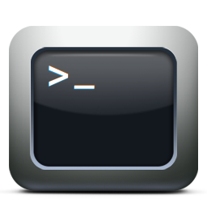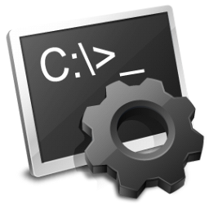

Table des matières

What are these scripts for? 2

Pre-sets 2

General Menu 3

Other scripts 5

Opensession.bat 5

Appenddata.bat 5

# What are these scripts for?

The scripts presented here are designed to work with Multitech Multiconnect Conduit (MTCDT) and Python Programs ‘Decodeb64.py’ and ‘Map_Generator.py’.

They are useful for almost every common action, and are available for the 2 gateways.

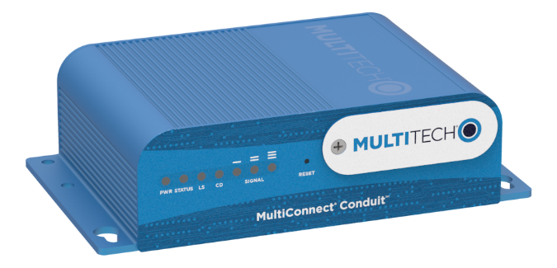

Figure : Multitech Multiconnect Conduit

# Pre-sets

We dispose of 2 gateways already configured to run the MQTT client ‘Mosquitto’.

**Gateway ‘Laurent’ IP: 192.168.2.1**

**Gateway ‘Etienne’ IP: 192.168.2.254**

Even if their IP range is the same, they DON’T belong to the same network.

WARNING: To run the scripts, you MUST configure your Ethernet network card so it belongs to ‘192.168.2.X’ network. See in appendix to see how to do so.

Paths written in these scripts are absolute, so they will only work for ‘connecsens-zatu’ for now.

All the scripts are available for the two gateways, but the only thing changing is the IP address and the name of the file.

# General Menu

A menu, giving access to all different scripts, can be found under the form of a .bat or .exe file.

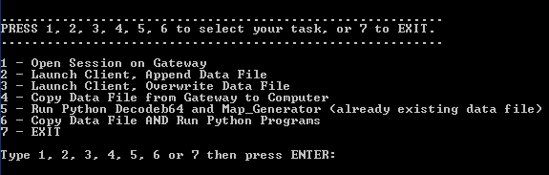

Figure 2:Main Menu when executed

While a .exe can’t be modified, the .bat version, available in scripts/For Gateway ‘name’/menuname.bat can be opened and modified by right-clicking on it, then left-clicking on ‘Modify’.

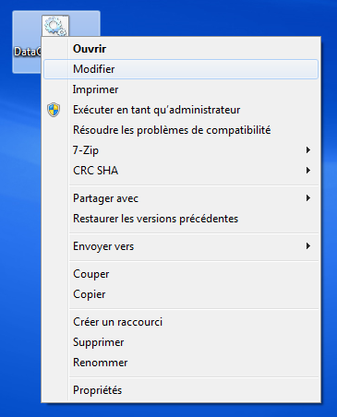

Figure 3:An example in French, under Windows 7

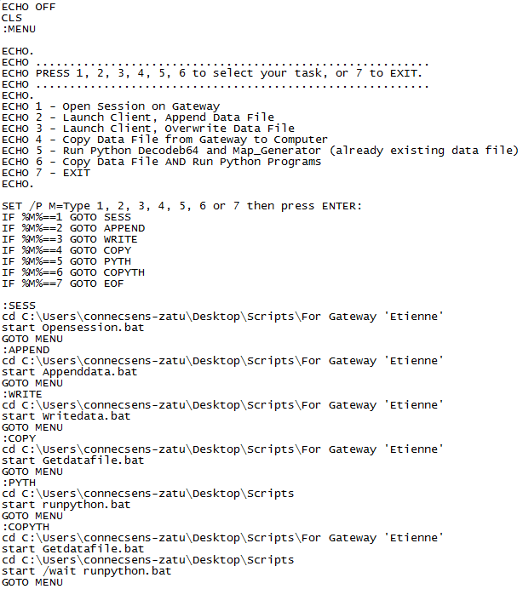

This is the code of ‘menuetienne.txt’. It is long, but simple:

1 – ECHO OFF and CLS are allowing to wipe the screen before executing the script.

2 - :MENU (and :SESS, :APPEND, :PYTH, etc…) are like paragraphs this script will have to refer to. It indicates where the menu must go, and when.

3 – set /p is a switch allowing user to input something in the program. Here, it will be an integer between 1 and 7.

4 – The input is set into a variable, named M (M=Type 1,2,3,4,5,6 or 7 means M will take the value of a number between 1 and 7.

5 – Setting of what the input does. For each number, the program goes to a “paragraph” (:STHG)

6 – Each ‘paragraph’ opens a script, set in an absolute path. If you are using this program on a different computer, you will have to change these paths by the new one your scripts are in. Then the program goes back to the menu, so you can execute another command if needed.

# Other Windows Batch scripts

## Opensession.bat

Is executed by tying “1” from main menu, or double clicking on it in its folder.

Allows to connect to a Multitech gateway and log in automatically.



1. Set the program in PuTTY folder, so we can execute it.
2. Launch putty with Gateway IP address, with -pw parameter so you don’t have to enter a password.

WARNING: YOUR PASSWORD IS HERE IN CLEAR, DON’T LET PEOPLE SEE IT. FOR MORE SAFETY, YOU CAN REMOVE THE ‘ -pw root’ part.

## Appenddata.bat / Writedata.bat

Are executed by typing “2” or “3” from main menu, or double clicking on them in their folder.

Allows to execute ‘append.sh’ or ‘write.sh’ scripts on the gateway (see ‘On-Gateway Scripts’)





Plink is a little PuTTY utility allowing to execute remote scripts. It works in the same way than opensession.bat.